Module 1 Exam

Name: Abhishek Mhatre Set - B

**Shell**

1. Shell script program to check if a given year is a leap year

First we create leap.sh file

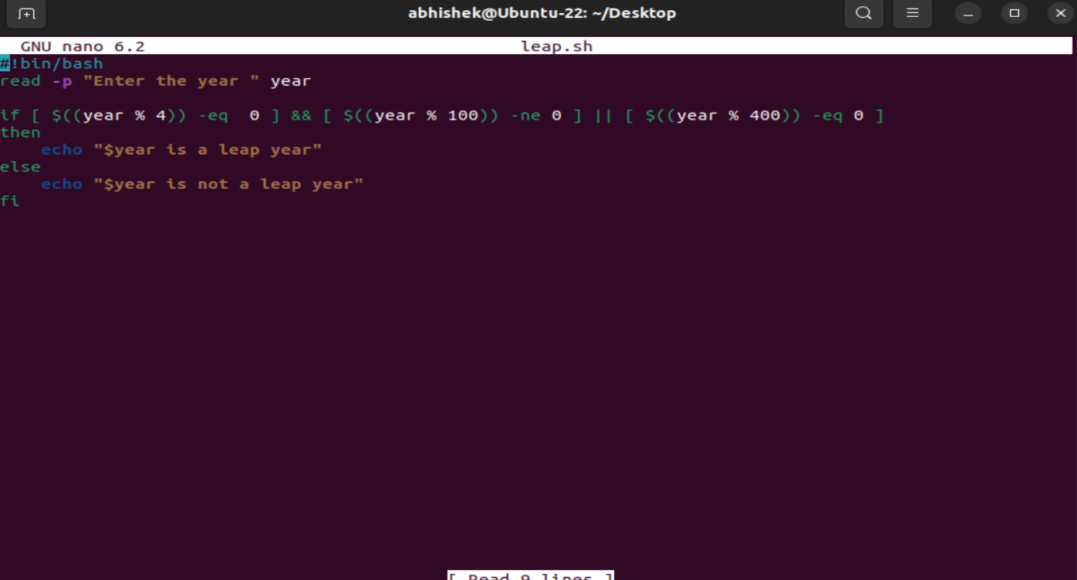

Then we run the program

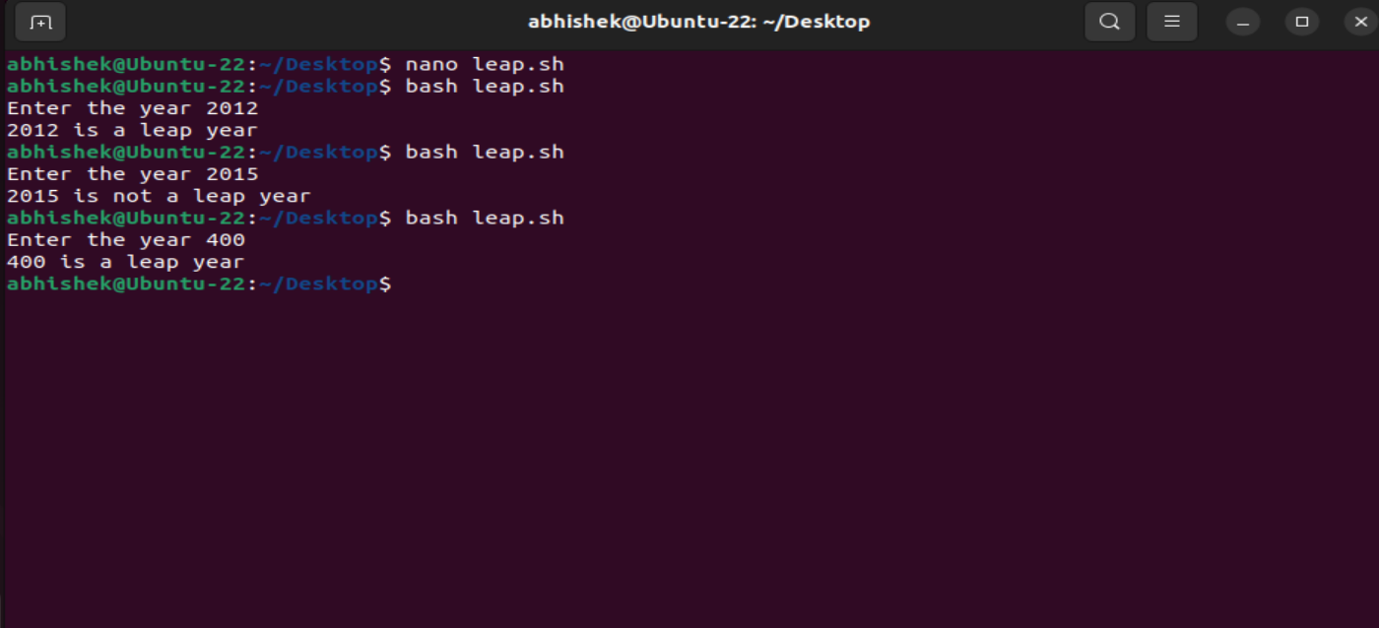

2.shell script program to print fibonacci number upto a certain number

Create file fibo.sh

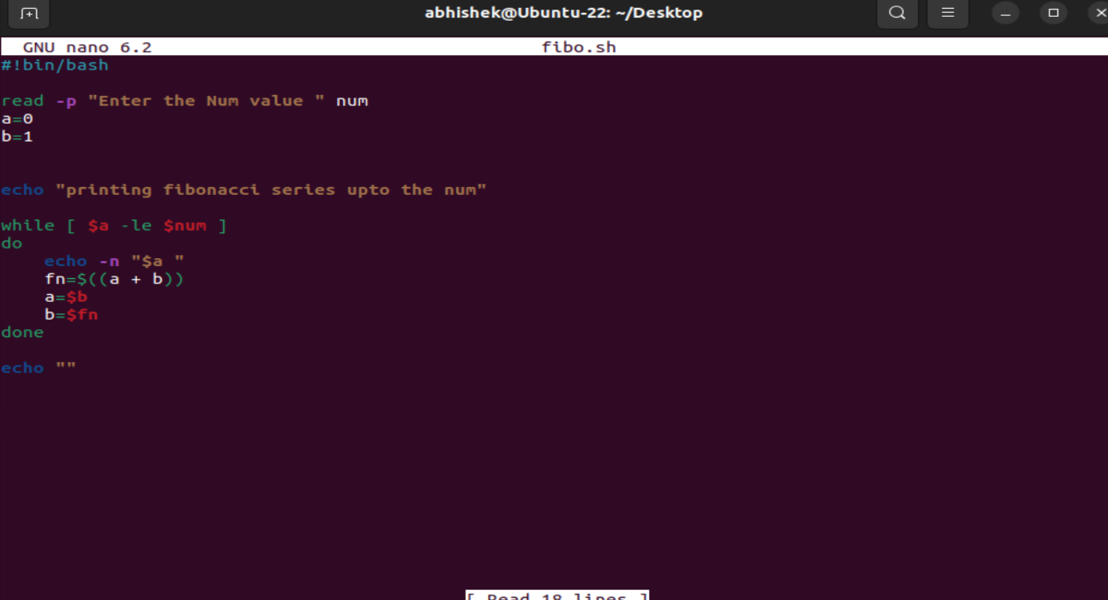

Then we run the program

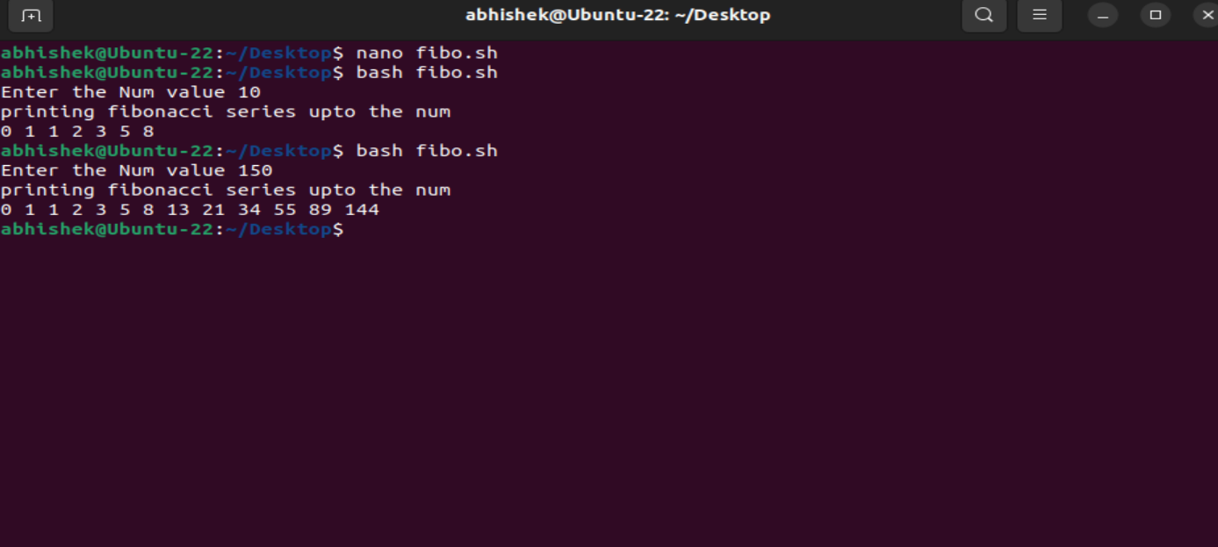

3.Linux Commands to write a file management commands that allows users to perform following functions

1. Create a new directory with specified name

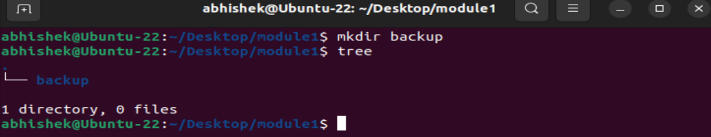

1. Rename an existing directory with a new name

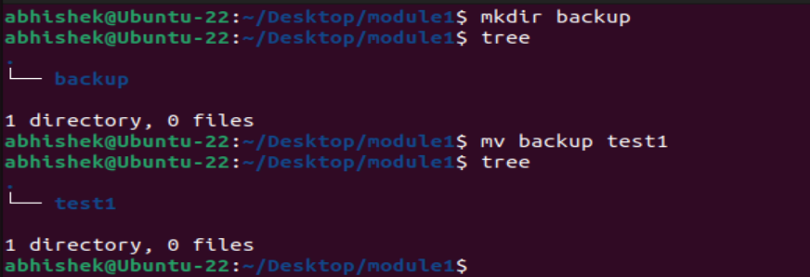

1. Move an existing directory to a new location

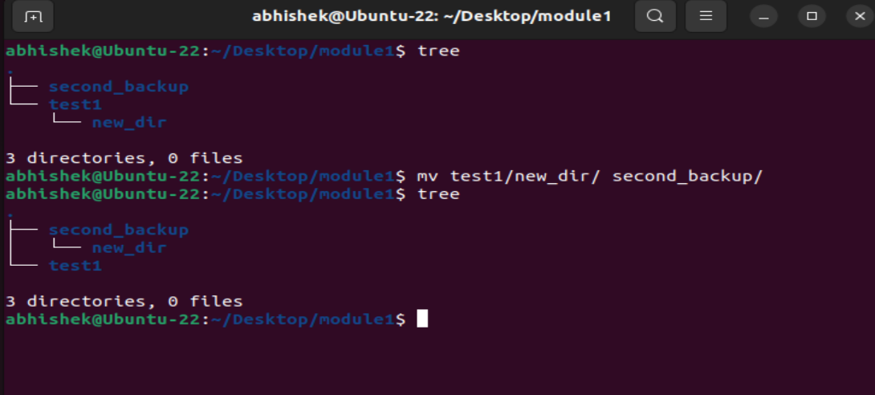

1. Delete an existing directory

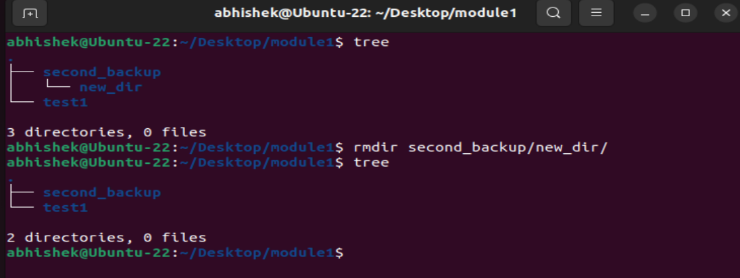

1. Create a file and name it as file1.txt and create a hardlink to this file

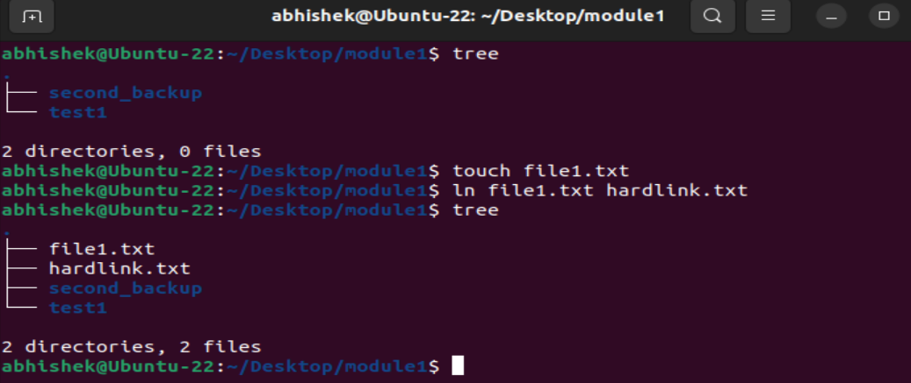

**Cloud**

1. Create a linux ec2 and access the ec2 through putty on your system and create a html page and make it available on a public ip address

First we search EC2 in AWS Console and click it

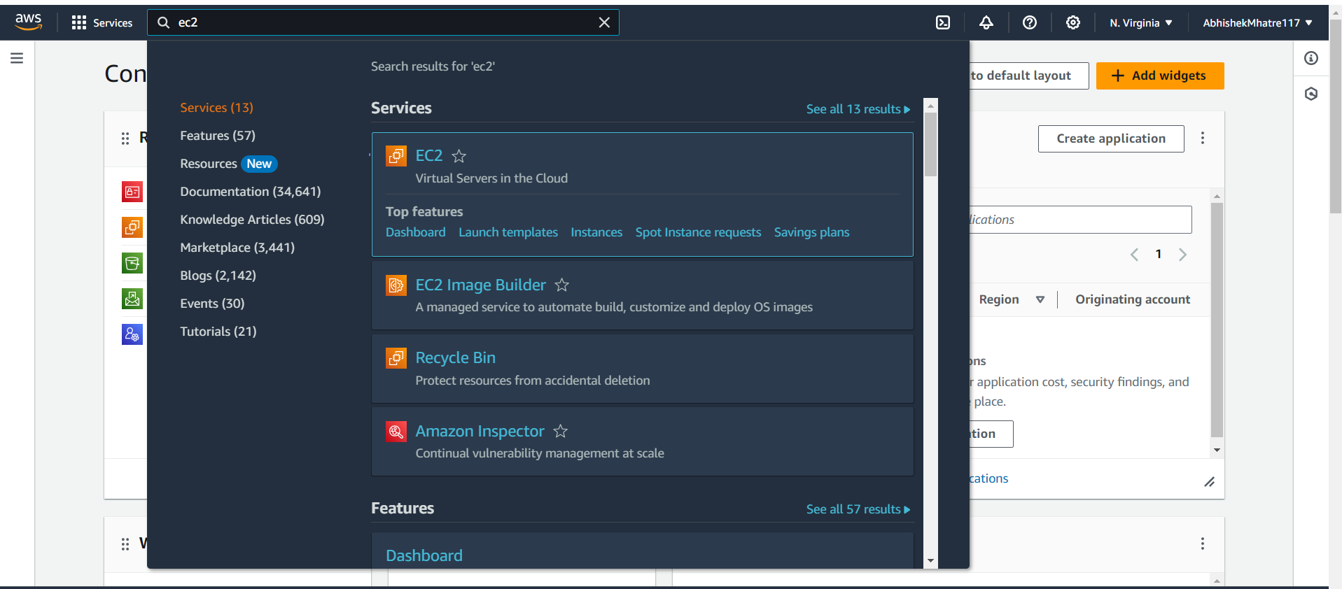

Then we create a instance and give a name to that instance

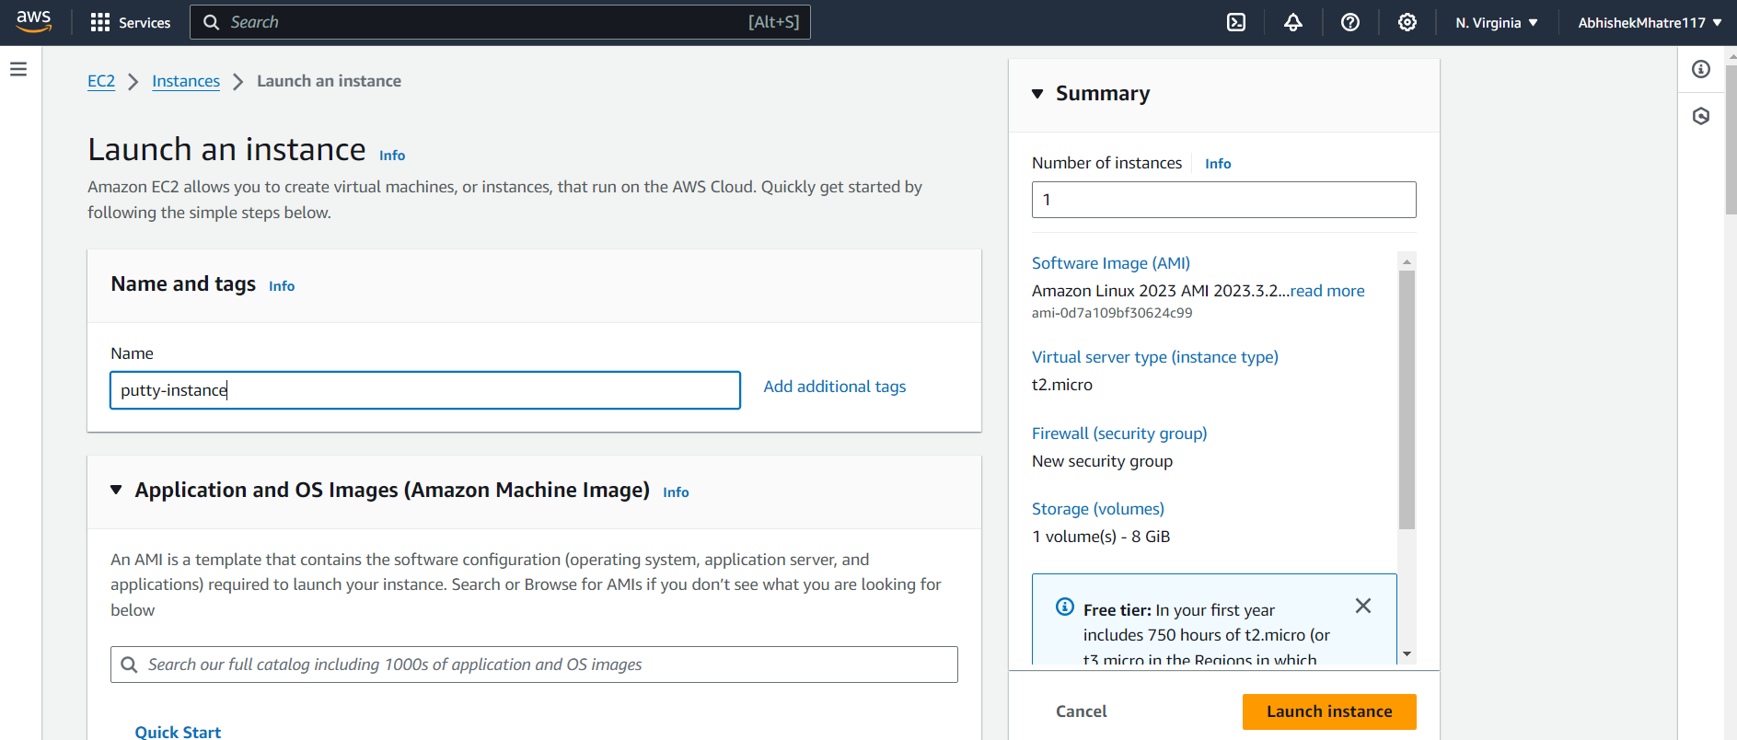

Then we scroll down and select the key-pair

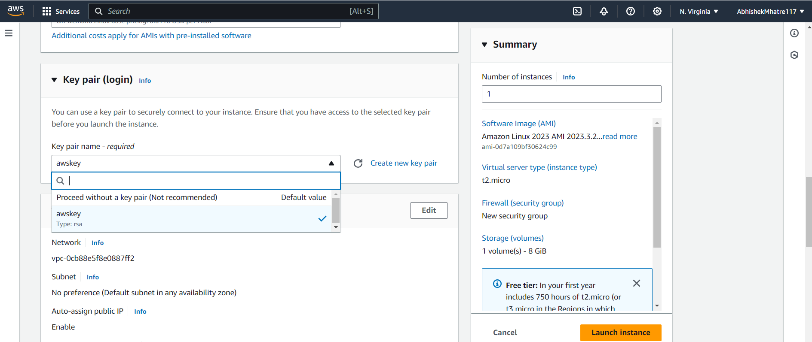

Also in network setting we need to allow both http traffic checkboxes

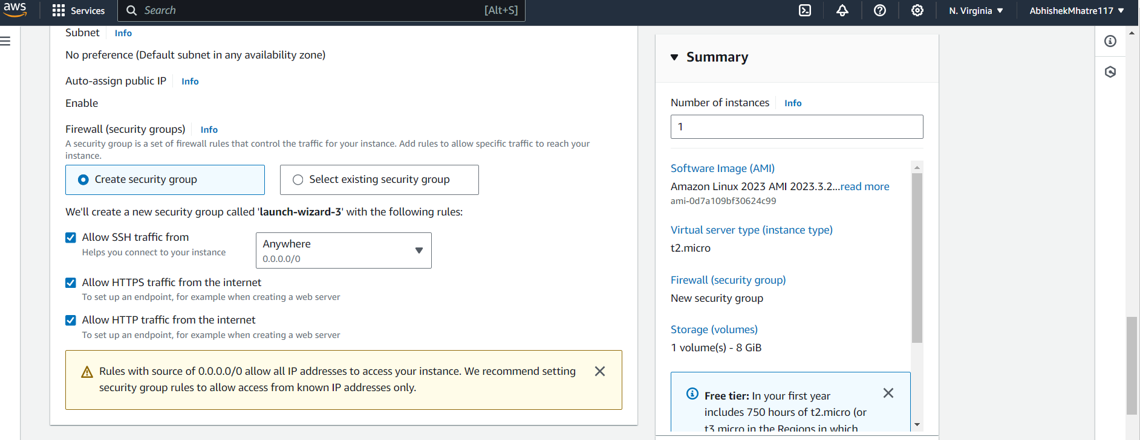

Then we click on launch instance

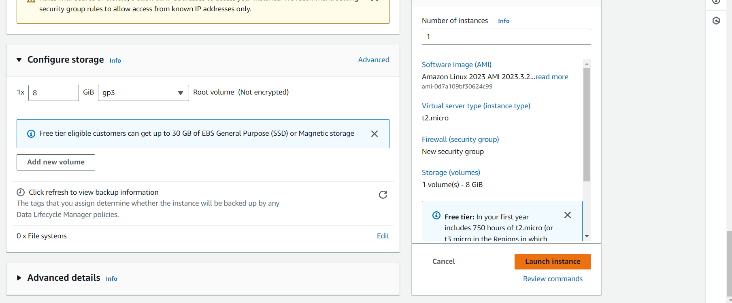

Then under instances tab we can see our instance is created and running

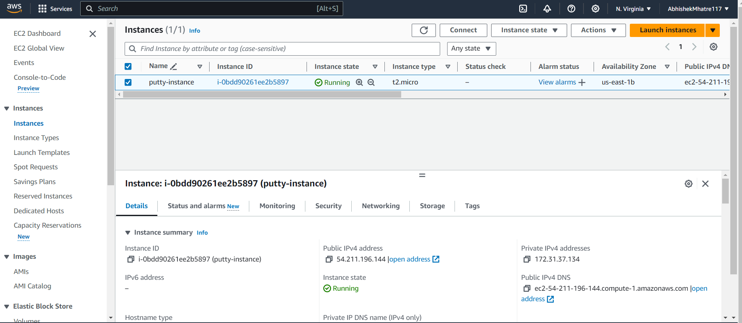

Then open putty application then in host name give name as ec2-user@Ip_address(of the instance that was created)

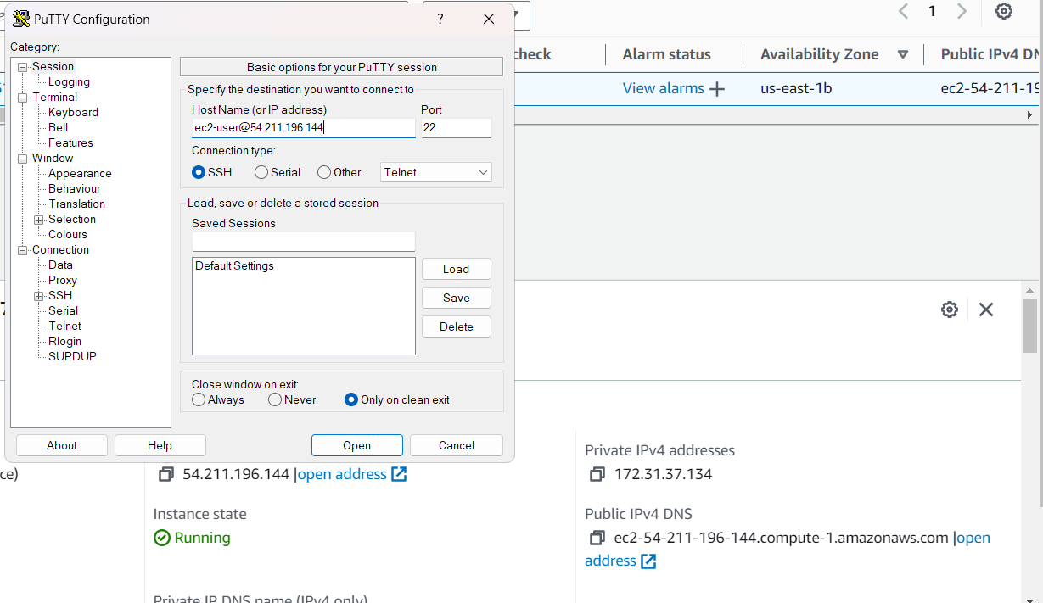

Then go in SSH then click on Auth then click on Credentials

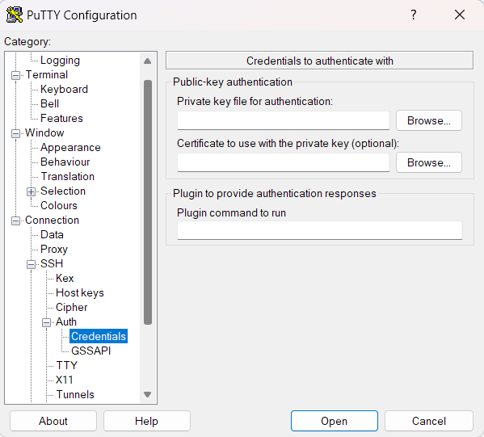

Then browse the same key-pair key you used to create the aws ec2 instance

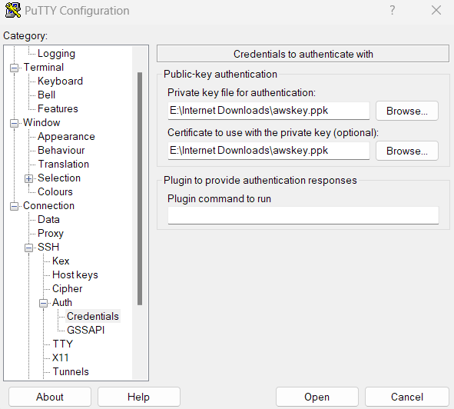

And then click on open then it will give you a security pop-up then you need to click on accept

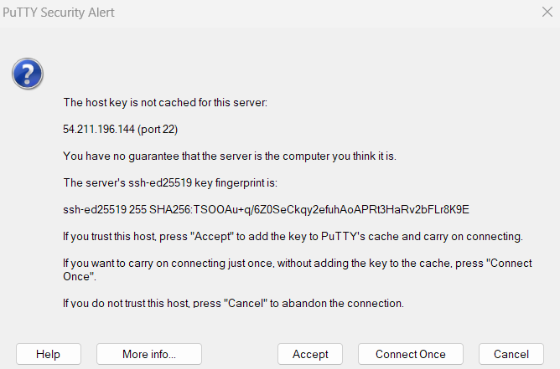

Now putty is connected to the ec2 instance now we can run commands

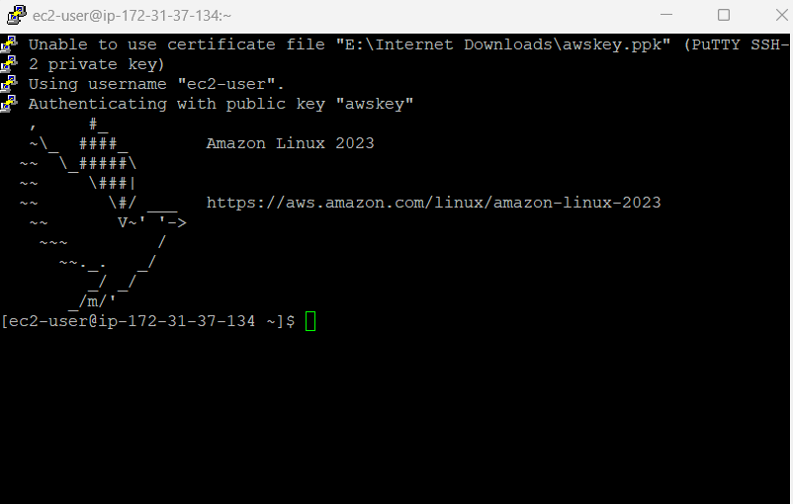

Now we do sudo -i and then yum update -y

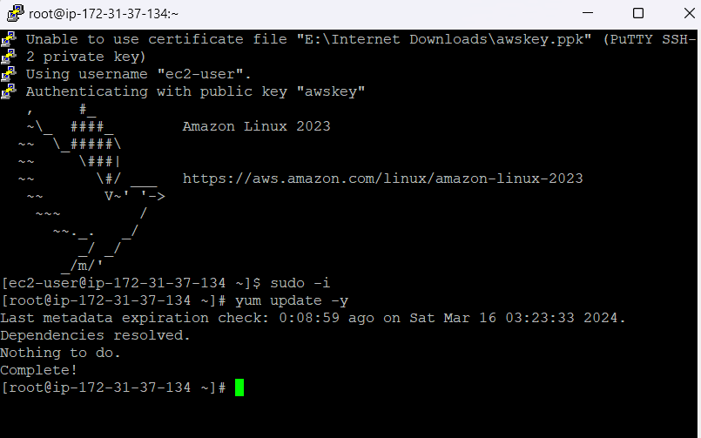

Then we need to install yum

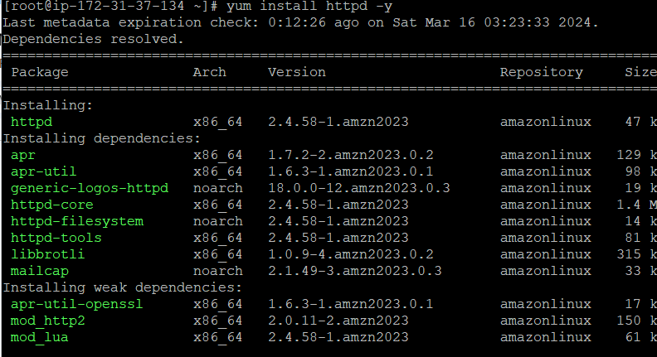

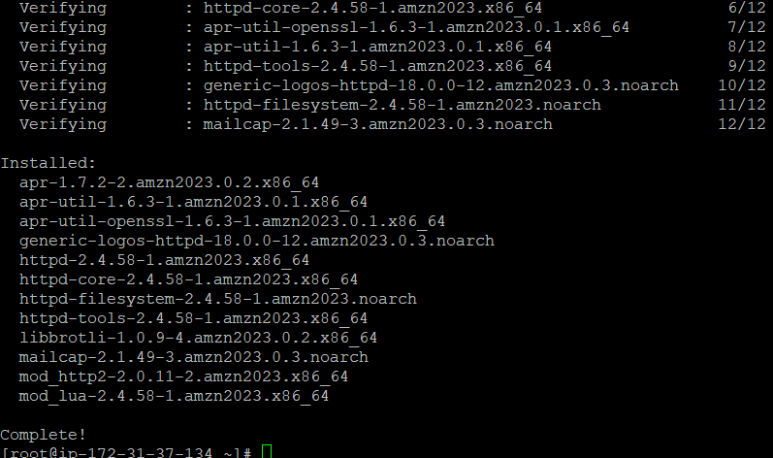

Then we need to start httpd using systemctl and check its status also enter ctrl+c to exit the systemctl status command

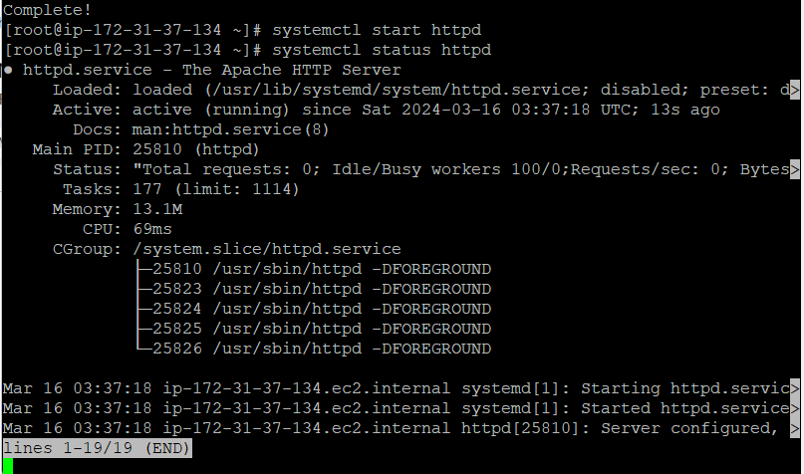

Then we need to enable httpd using enable command

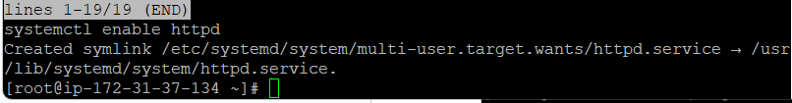

Then we need to browse to the html directory /folder and create the html file there

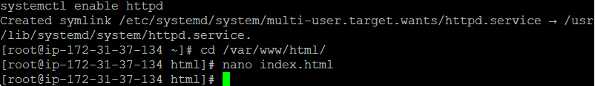

Index.html file contents

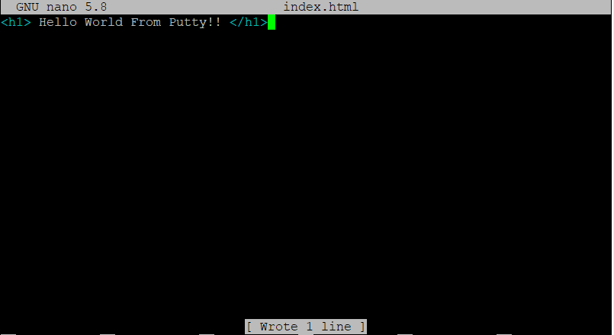

Now we to go the google chrome browser and enter the ip-address of our ec2 instance and check whether it displays the message return in the index.html file

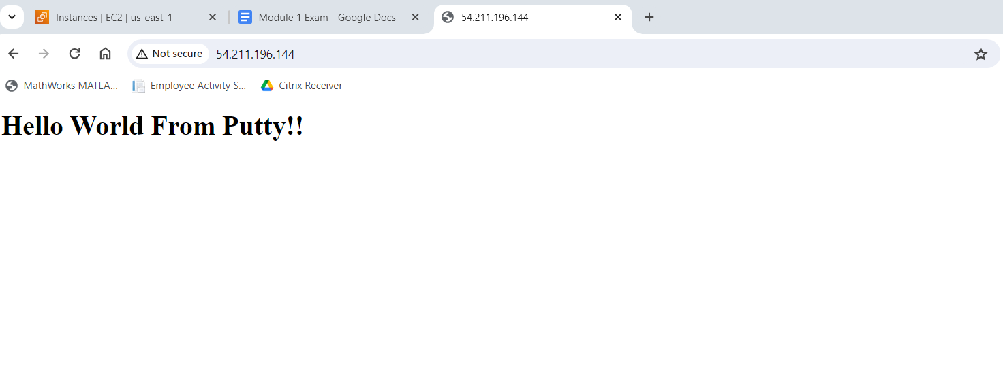

Successful it shows the index.html message on the browser

2)Create a vpc with 2 subnets , 1 route table and 1 internet gateway

Search vpc in aws console and click it

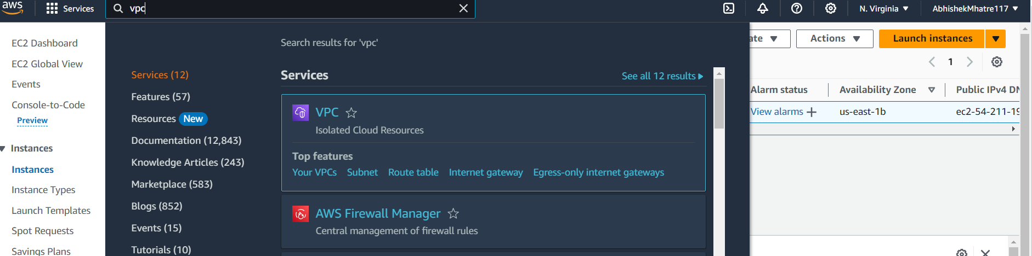

Click on create vpc and give it a name

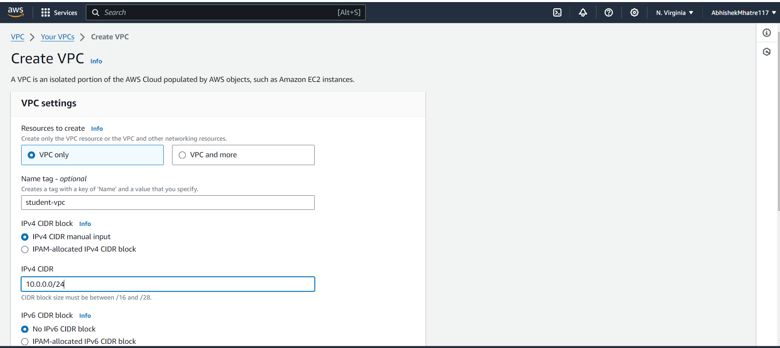

Click on create vpc

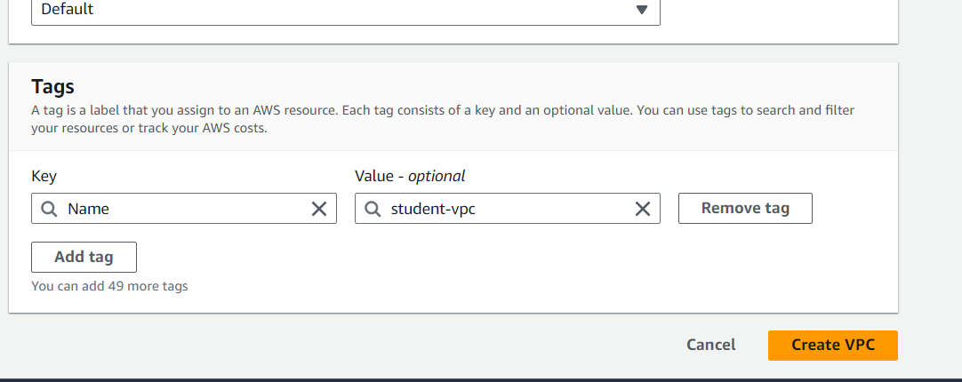

After creating vpc click on actions then on edit vpc setting and enable dns hostname and save changes

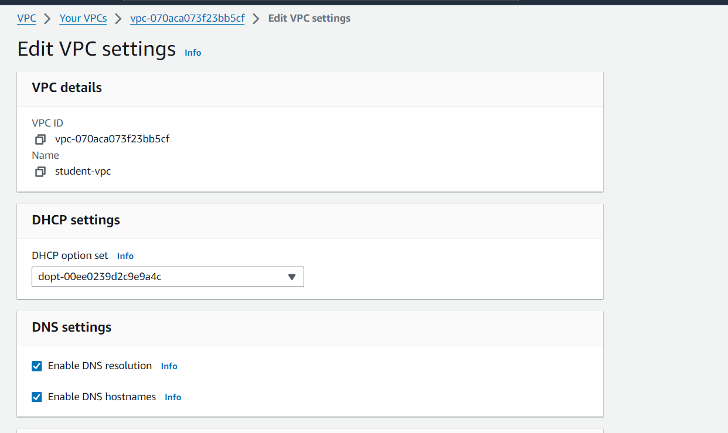

Initial resource map

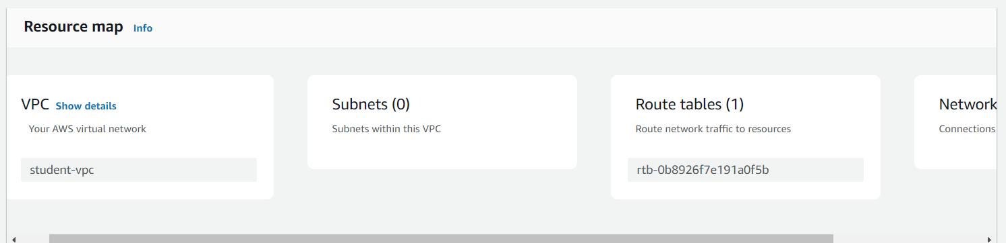

Now go to subnets and create a subnet and select vpc that you have created and give name to it

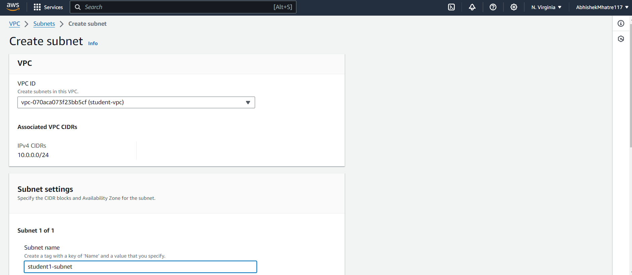

Now go internet gateway tab and click on create internet gateway and give name to it

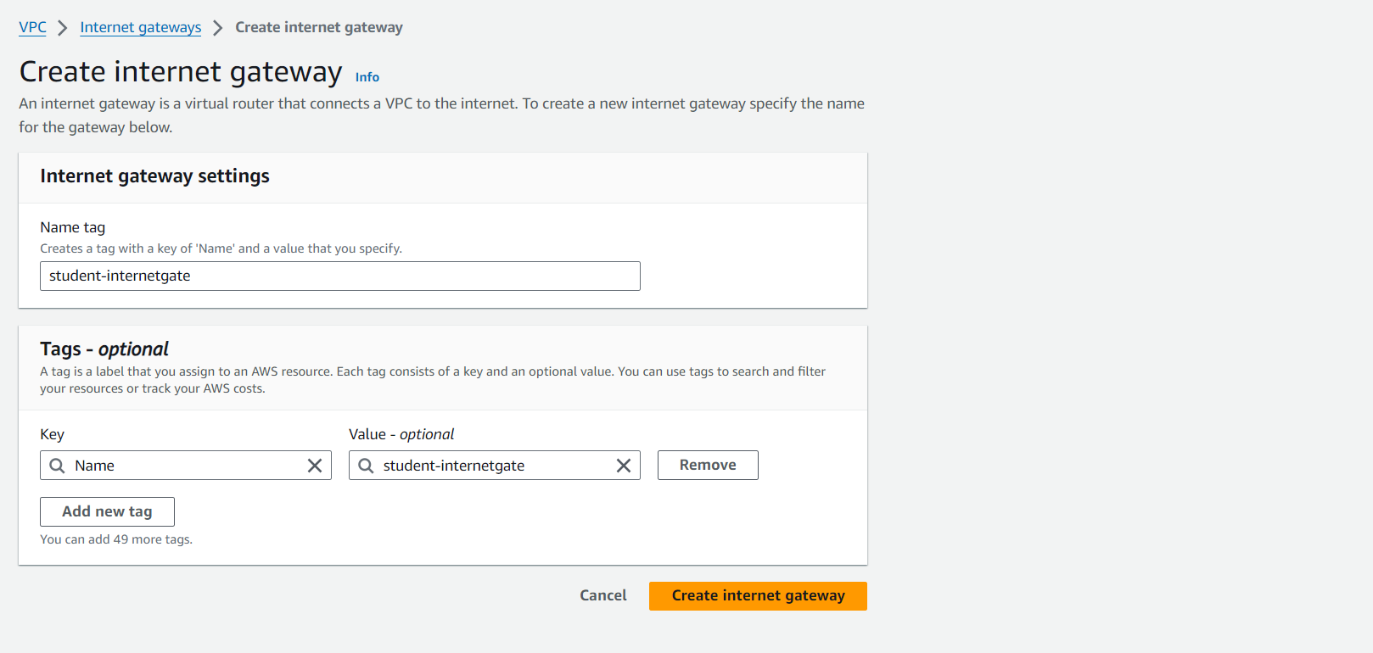

And then attach your internet gateway to vpc

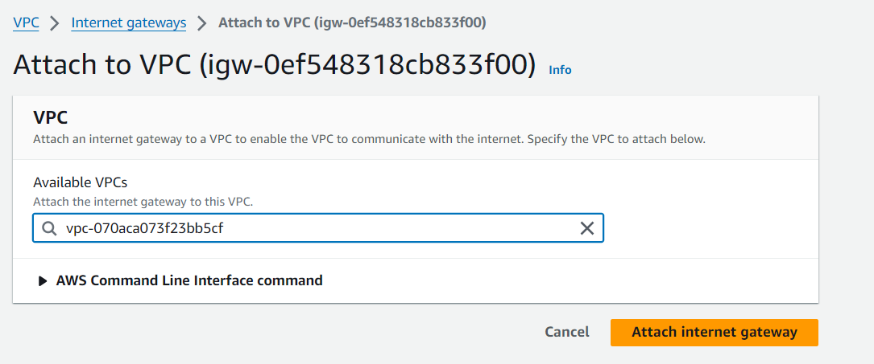

Now go to route table and create it and give name to it and also give the name of the vpc that we have created

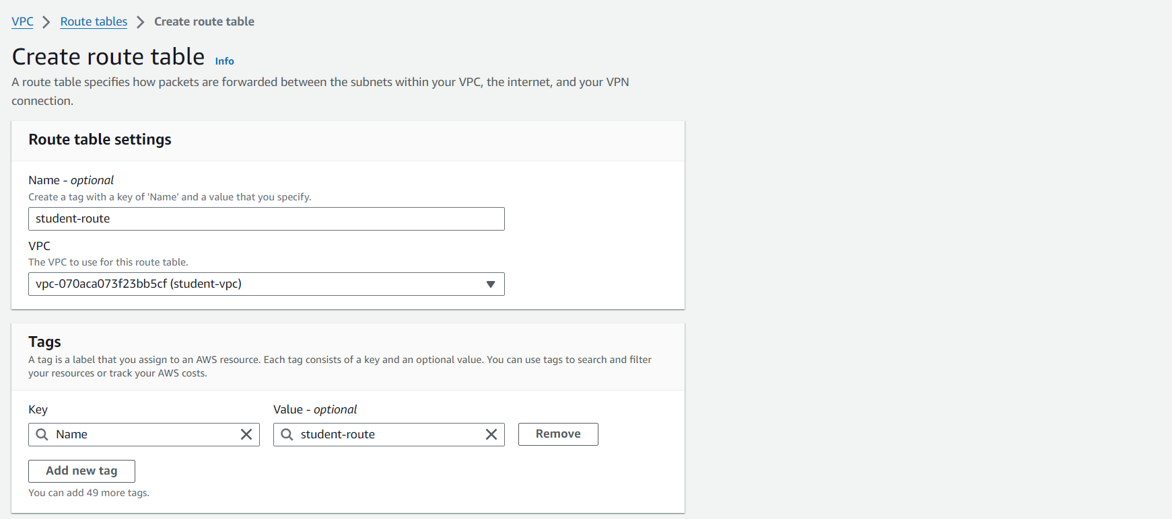

Now in route table click on actions then edit route and add out internet gateway there and then save changes

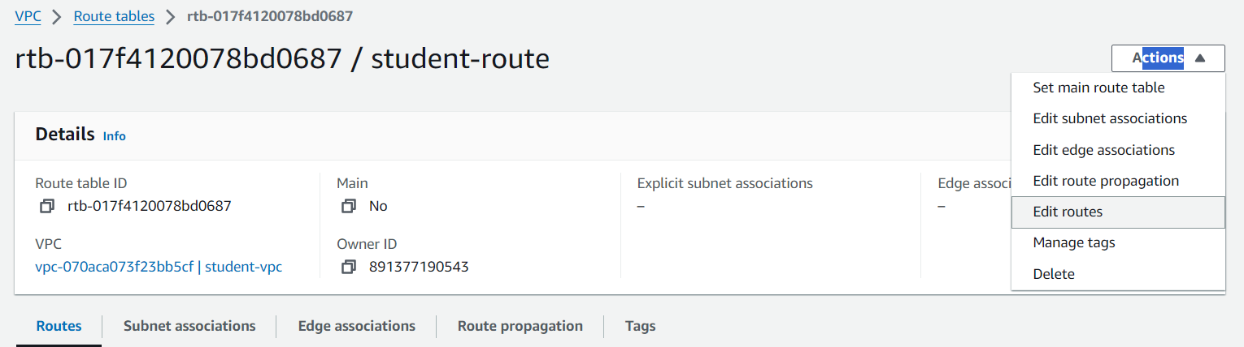

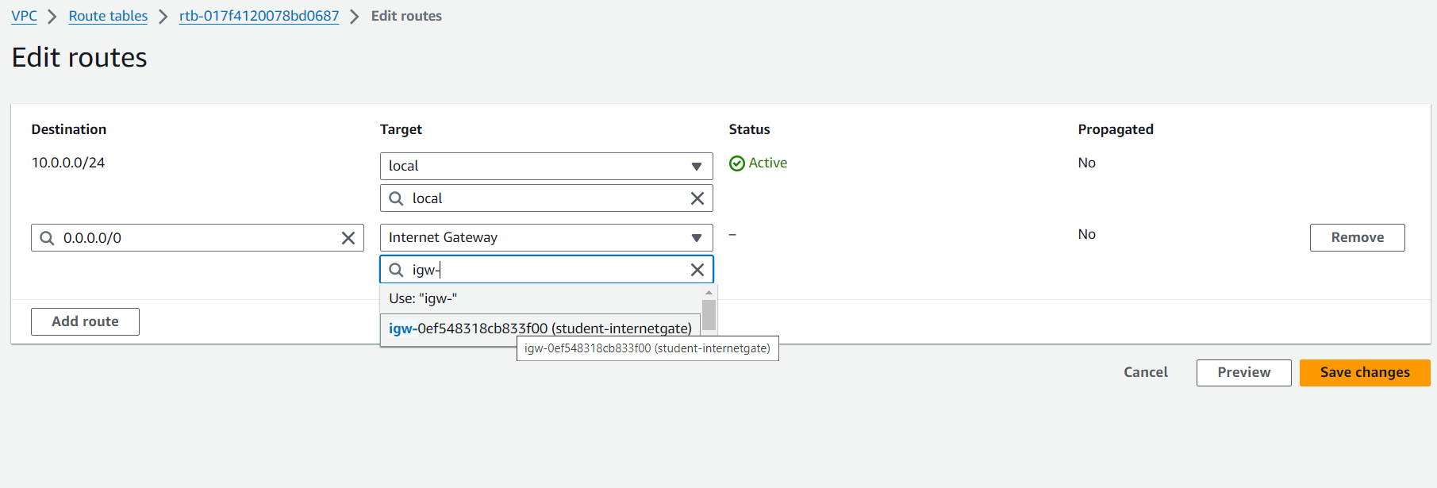

Now go in subnet section and click on the subnet that we have created then click on actions above then click on edit route tableassociation

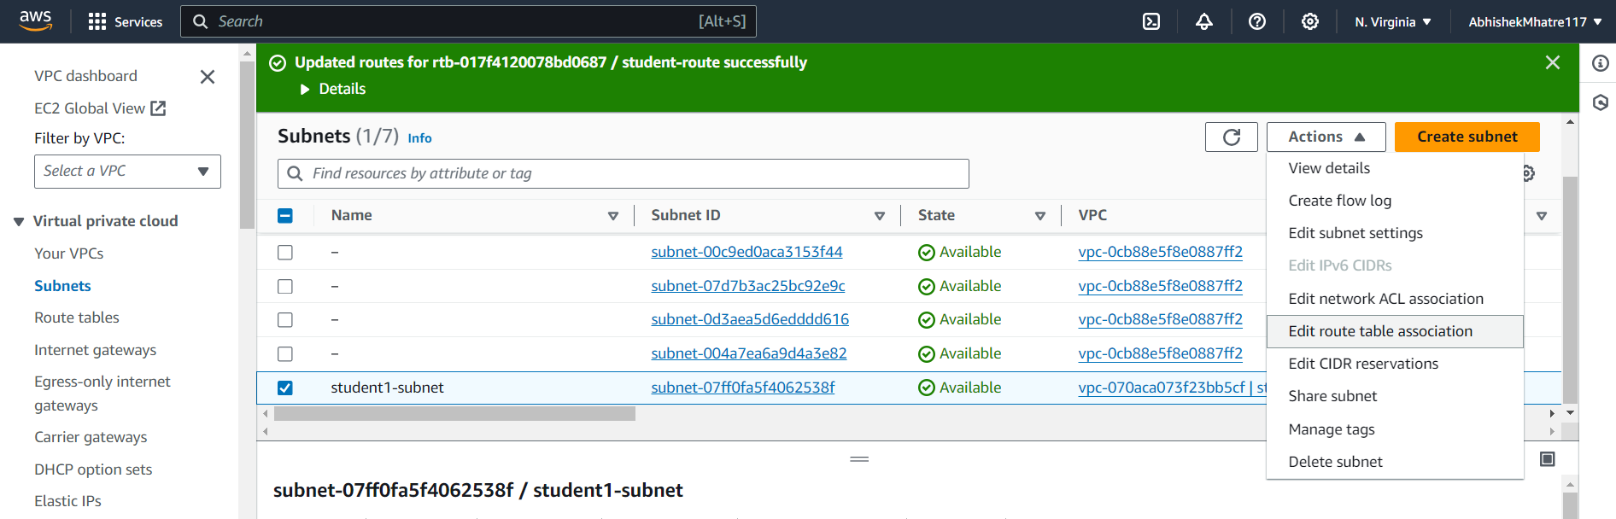

And change the default route table with the route table that we have created

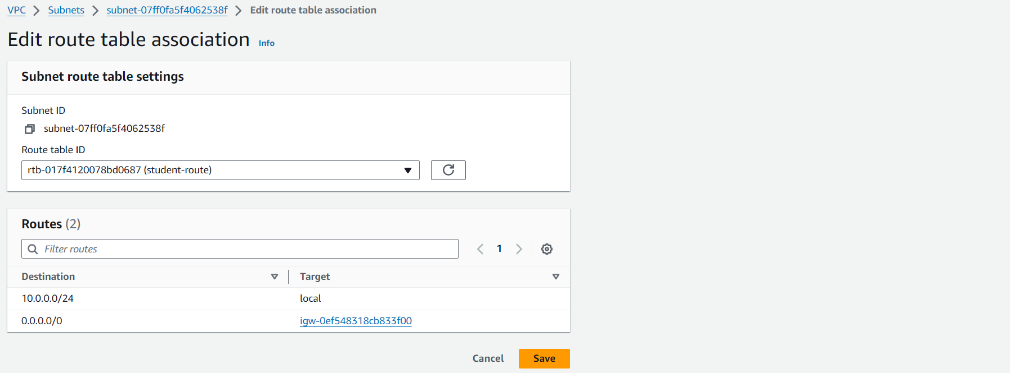

Under subnet only go to actions and edit subnet and tick on both the enable checkbox option and save it

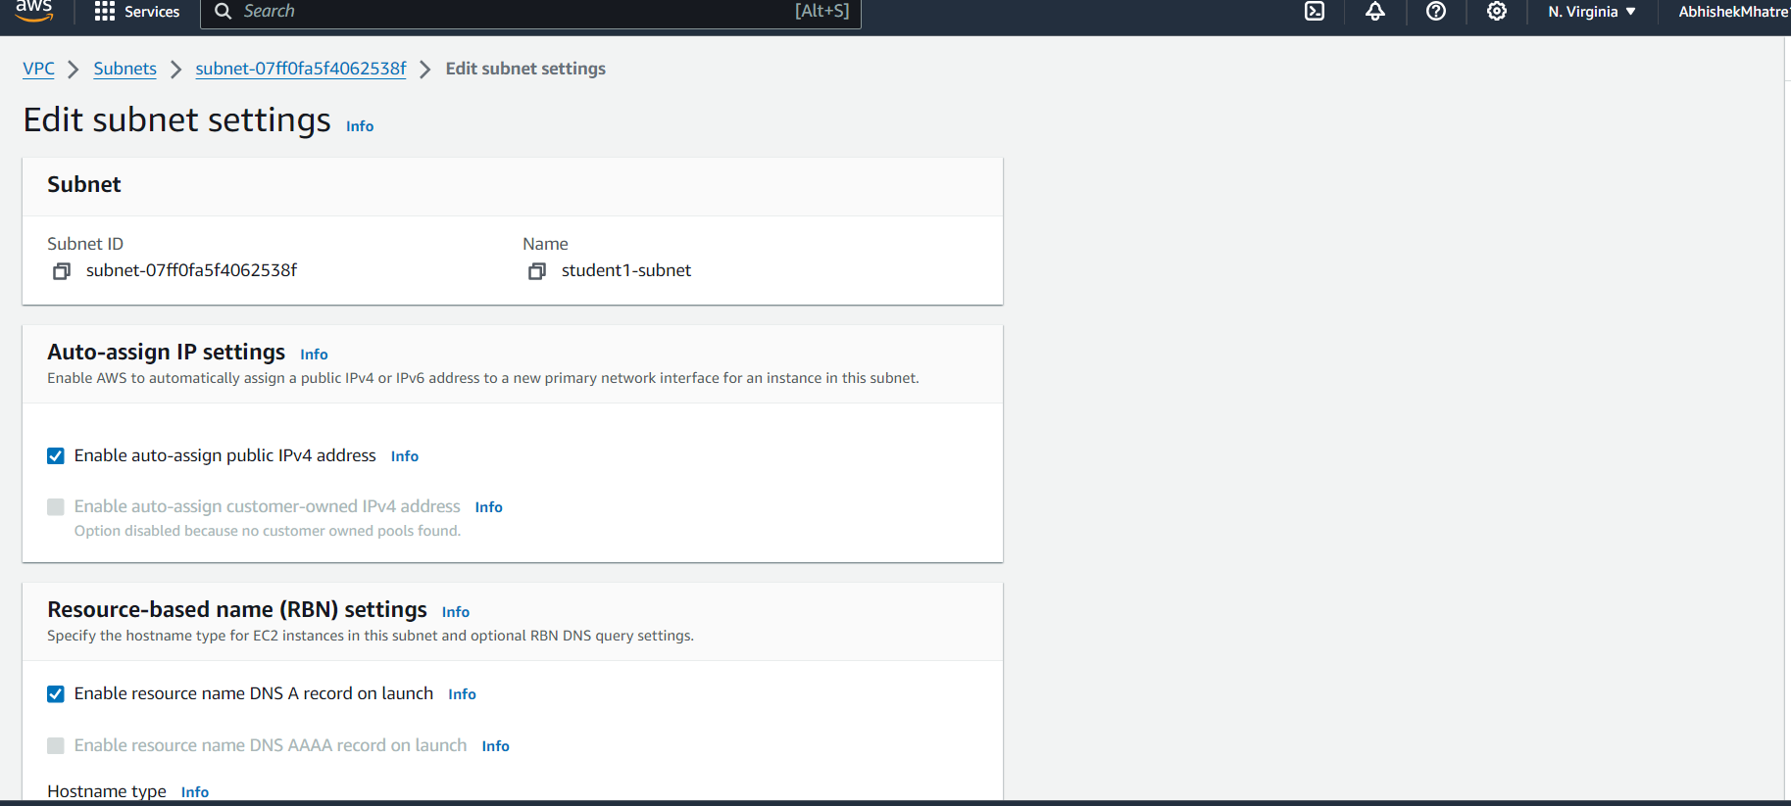

Now go to your vpc and check the resource map if everything is connected

If connected then it is successful

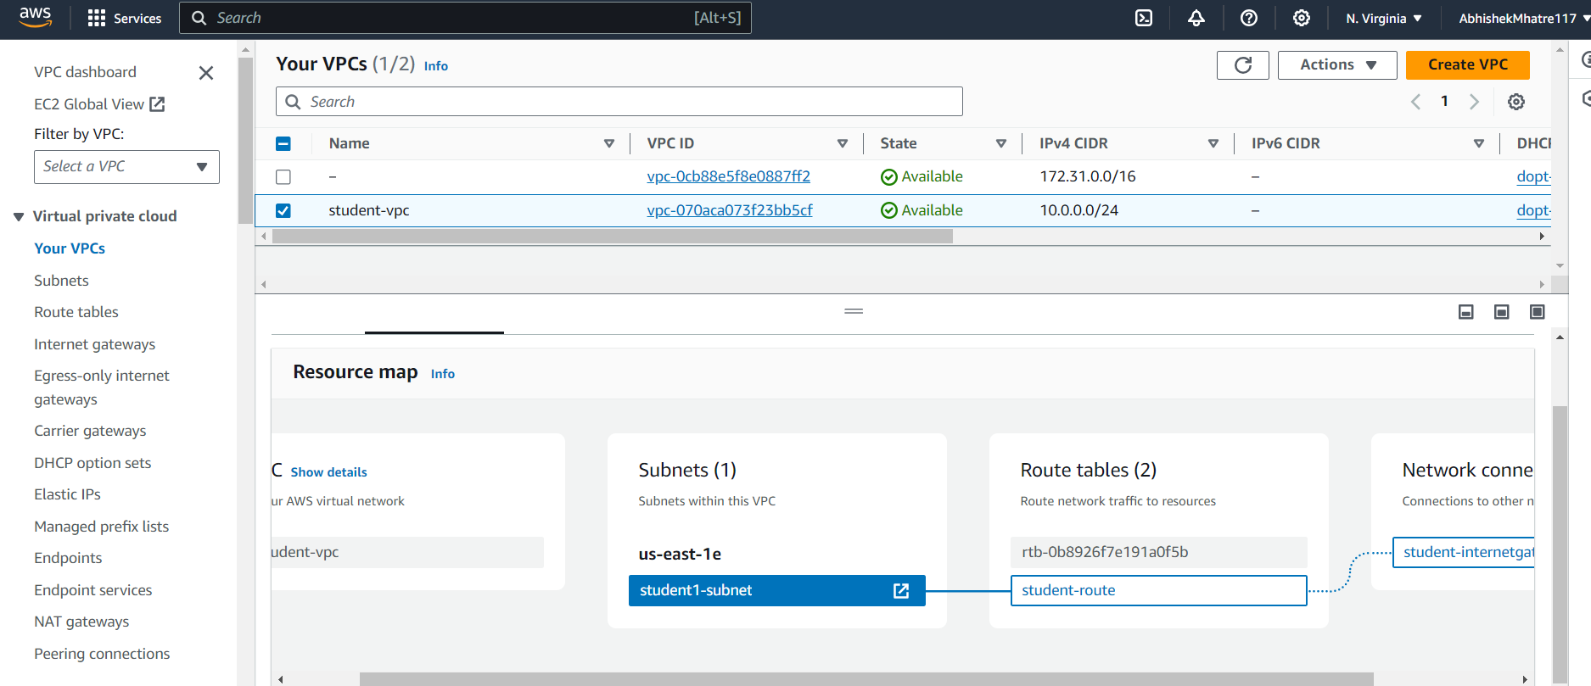done